**LAPORAN PRAKTIKUM**

**PEMROGRAMAN WEB**

**Judul: Javascript**



**DISUSUN OLEH**

**Reza Akbar Saputra M0520069**

**PROGRAM STUDI INFORMATIKA**

**FAKULTAS MIPA**

**UNIVERSITAS SEBELAS MARET**

**2022**

**Hasil Web**

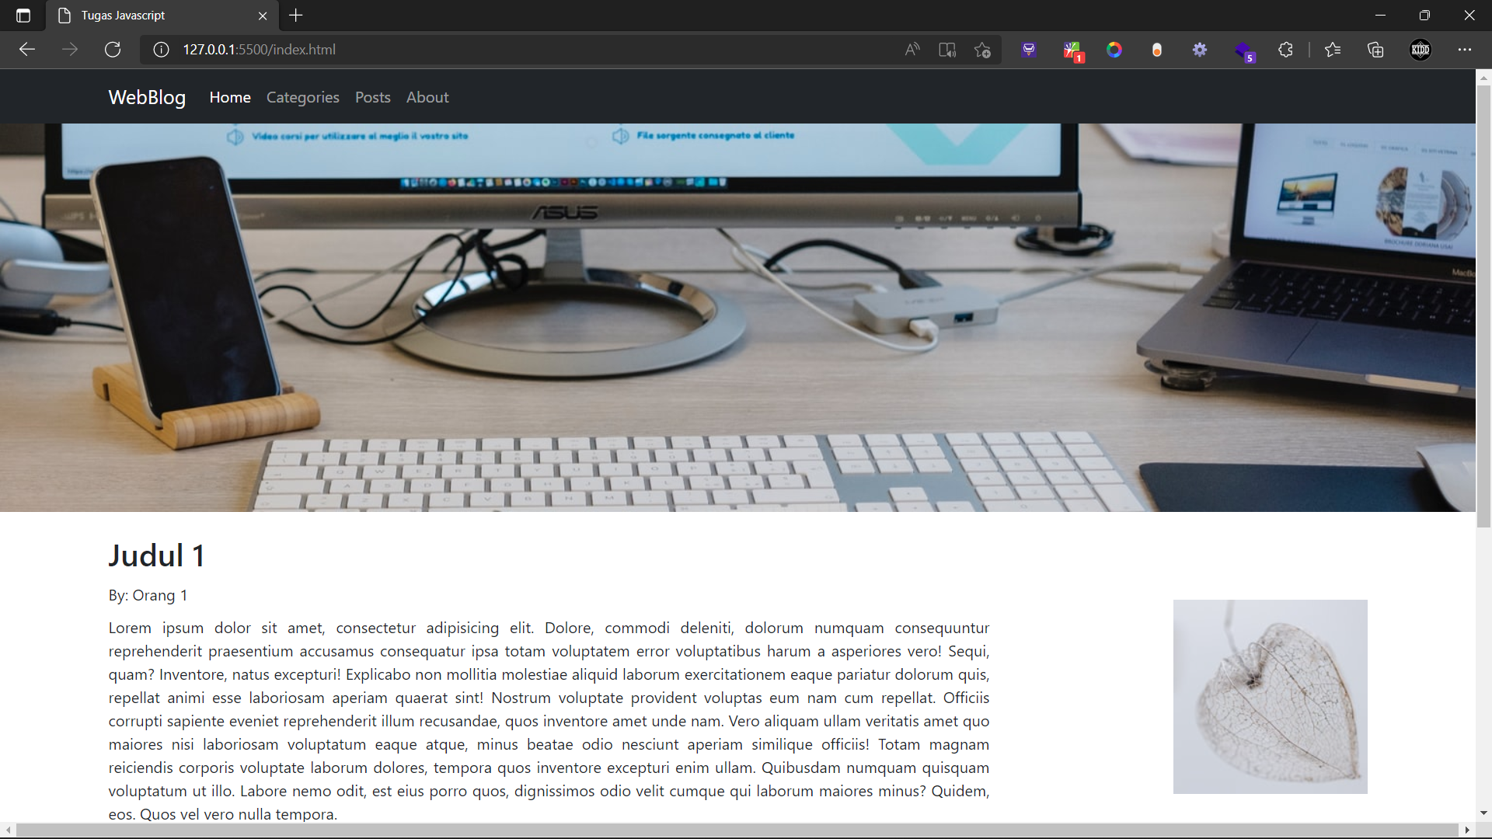

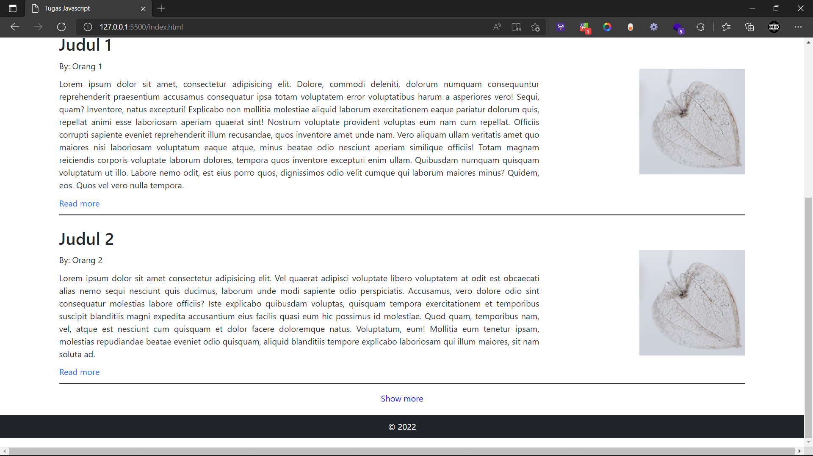

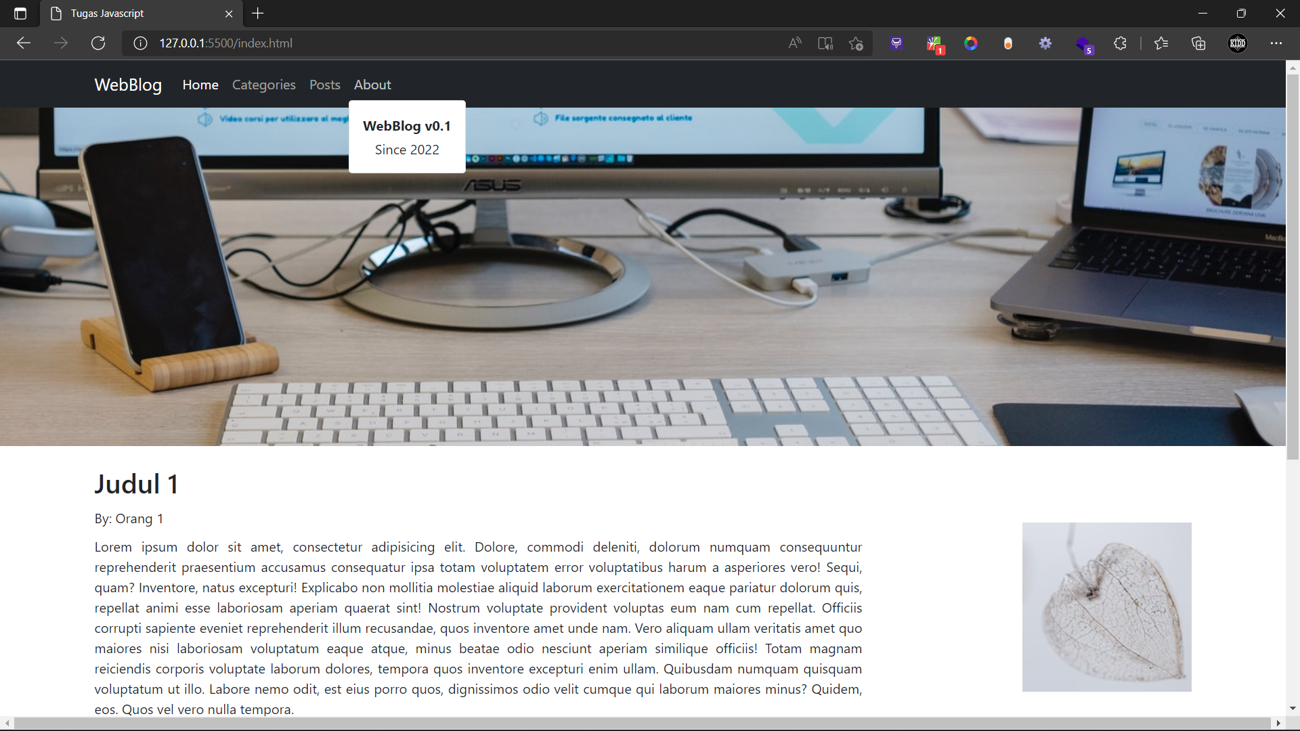

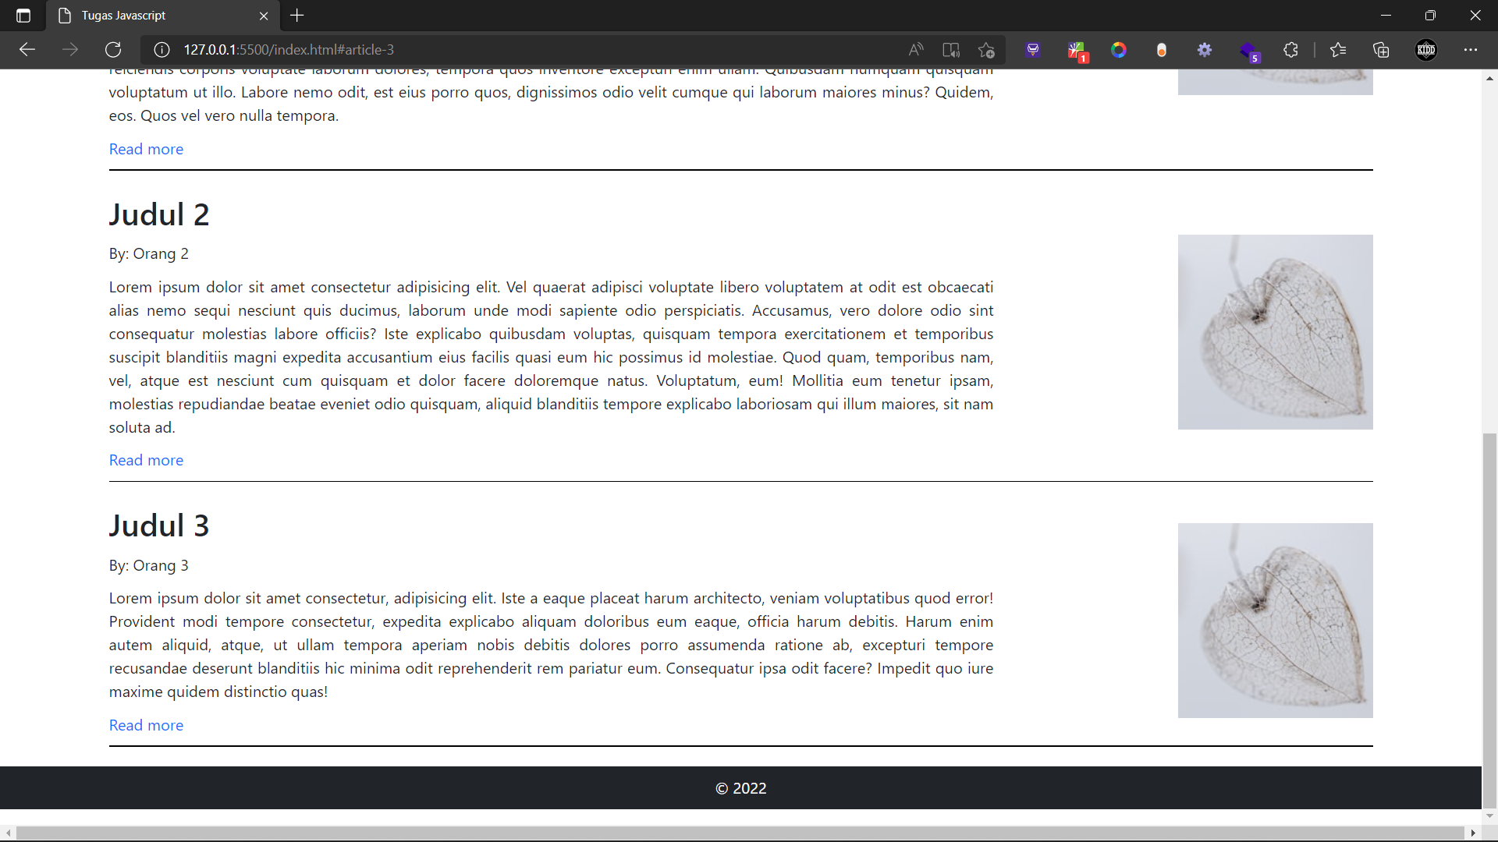

**Source Code**

1. **HTML**

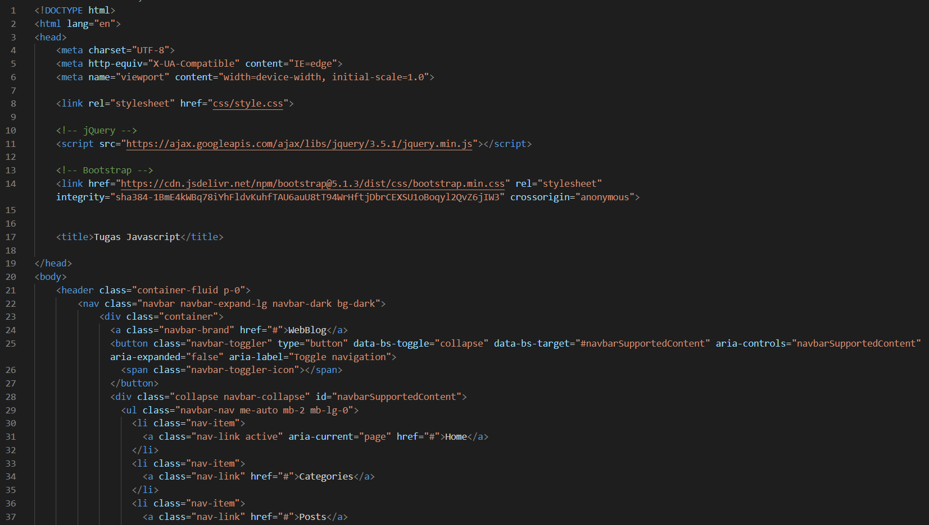

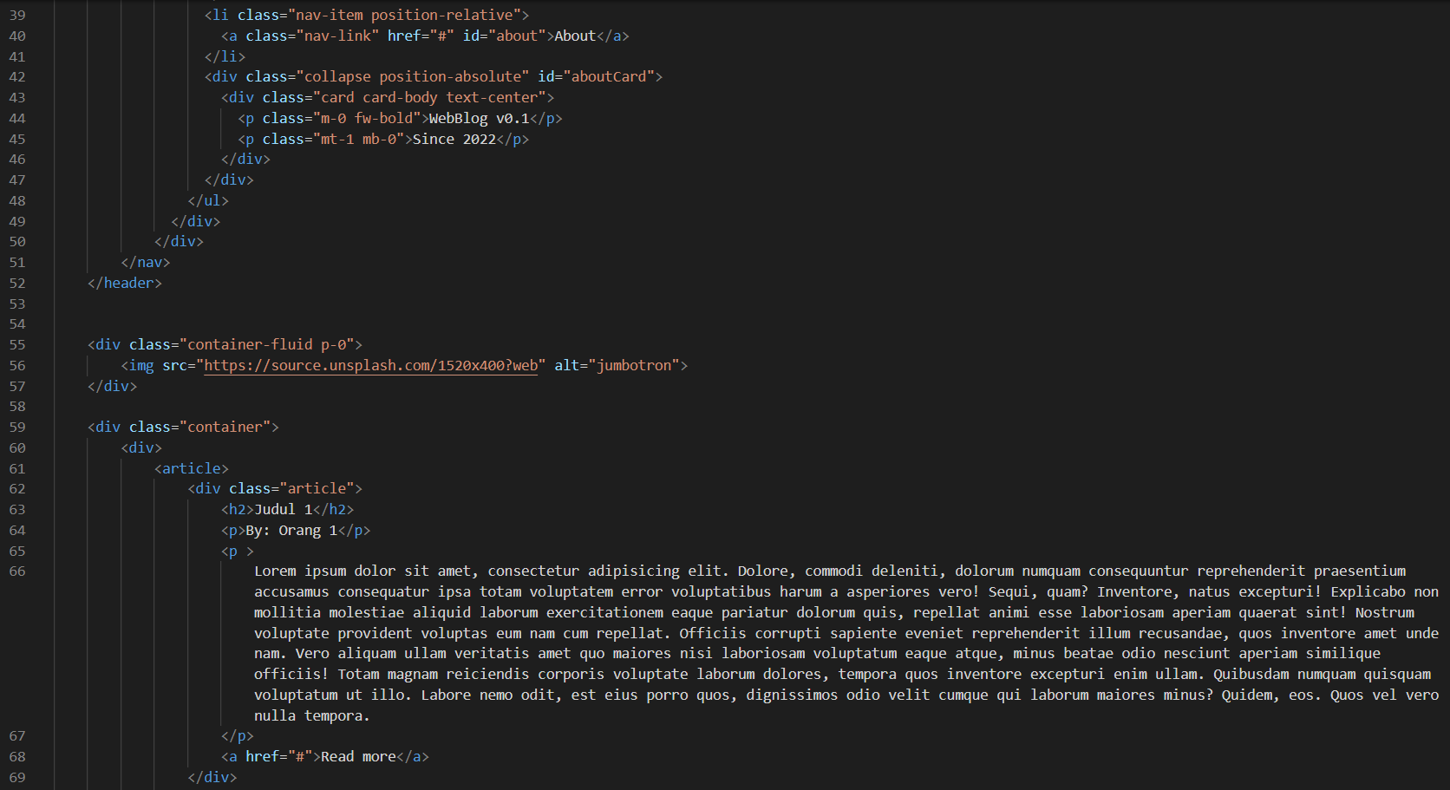

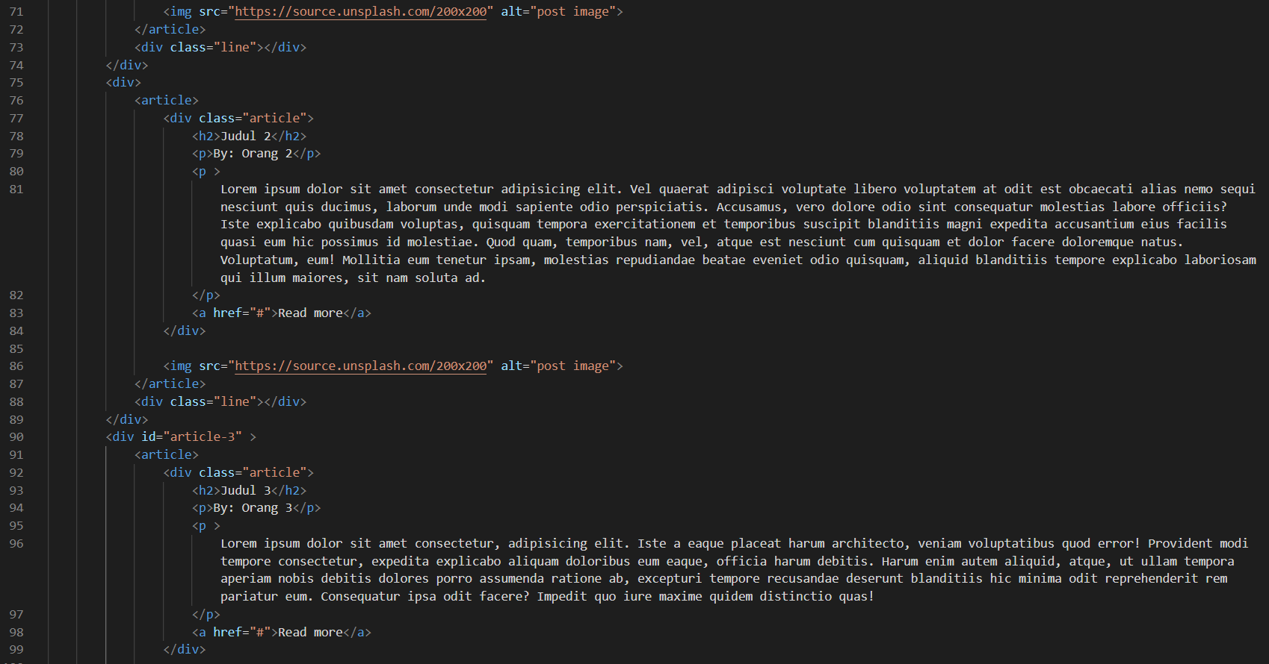

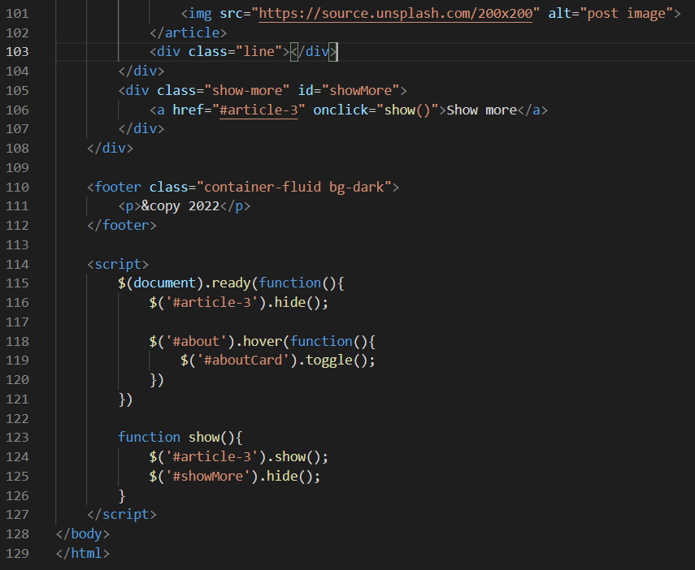

1. **CSS**

* {

    box-sizing: border-box;

    margin: 0;

    padding: 0;

    font-family:'Segoe UI', Tahoma, Geneva, Verdana, sans-serif;

}

#aboutCard {

    top: 6vh;

    left: 52vh;

}

article {

    display: flex;

    justify-content: space-between;

    margin-top: 1.5em;

}

.article {

    width: 70%;

}

article > img {

    width: 200px;

    height: 200px;

    align-self: center;

}

.article p {

    text-align: justify;

    margin: 10px 0;

}

.article a {

    text-decoration: none;

}

.line {

    height: 1.25px;

    width: 100%;

    margin-top: 10px;

    background-color: black;

}

footer {

    margin-top: 20px;

}

footer > p {

    color: white;

    padding: 10px 0;

    text-align: center;

}

.show-more {

    display: block;

    text-align: center;

    margin-top: 15px;

}

.show-more > a {

    text-decoration: none;

}

.show-more > a:visited {

    color: blue;

}